**Appendix B Software Requirements Specifications**

**PUBLIC VECHICLE COMPLAINT MANAGEMENT SYSTEM**

Panelist Name:

Mr. Glenn B. Pepito, MBA

Ms. Christine F. Peña, MMath

Mr. Gian T. Opone

Proponents:

Amit, John Mark

Gula, Jose Maria

Melchor, Alec Job

Ybañez, Vanvan

**Introduction/Rationale of the Study**

Public Vehicle Complaint Management System is a capstone project conducted by a group of students of the University of San Carlos enrolled under the degree program of Bachelor of Science in Information and Communications Technology. It is a system that enables public vehicle operators and public transport authorities to manage public vehicle complaints received from complainants from a mobile application.

Public transport quality can potentially improve through an effective complaint management system. In order to achieve this, the researchers developed a mobile-based complaint submission application and a complaint handling web application that enables the public vehicle operators to monitor and manage their vehicles and its complaints received. The system can also enable public transport authorities to utilize the statistical data and from verified complaints to have an effective traffic and public transport administration.

The mobile application is better on android devices with good GPS location capabilities and constant internet connectivity for convenient complaint submission. Operators can obtain their accounts to the system when the administrators registers them in the system.

**System Description**

Public Vehicle Complaint Management System is a web-based system and an android based application. The web based application handles of public vehicle operators and public transport authorities. The operators will manage their own vehicles that registered in their system to evaluate the performance through the complaints of the complainant. They will the one who approve and verify the complaints of the complainant through their contact numbers that given. The public transport authorities which are the LTFRB will manage the vehicles that are not belonging to any operators. They are also the one who will register the operators through the system.

***Type of Users:***

**Super admin (LTFRB).** Can manage public vehicle operators and complaints of vehicles without operators. The super admin can monitor all complaints in the system and utilize the data statistics to take action in public vehicle transport management.

**Operators.**  Can manage and verify complaints of its registered vehicles. The operator can also manage its vehicles by adding a vehicle, assigning or removing a driver and lastly manage all drivers under the operator’s management.

**Complainants.** Can submit complaints to public vehicles.

**Design Model**

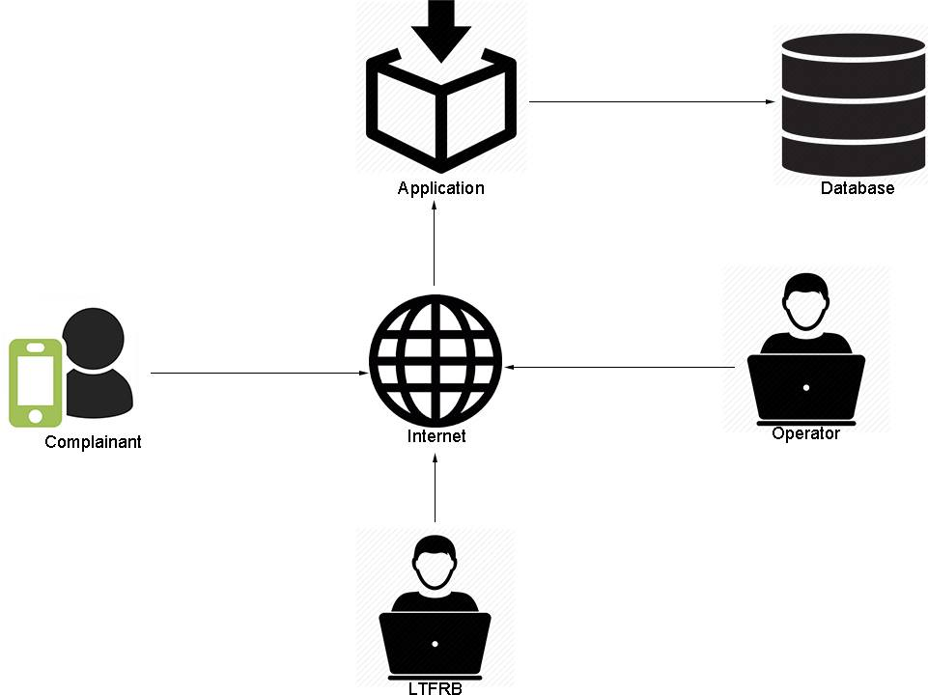

The complainant submits a complaint to a public vehicle then the complaint is sent and stored in the database by the application. The received complaints will then be verified by operators and super admins (LTFRB). The complaint data stored in the database will be interpreted statistically in graphs, records, etc. This data will be used by operators and super admins to improve their performance.

**System Flow/Development Process**

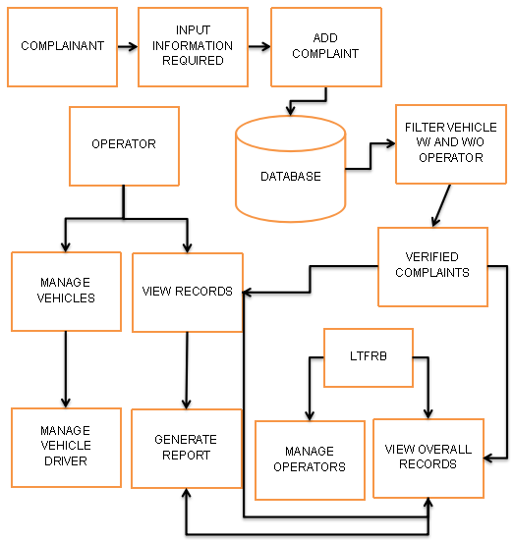

Public Vehicle Complaint Management System’s major components include: submission of complaint, complaint verification, driver and vehicle management, operator management and lastly the generate reports module.

**Android Application Wireframe of the Public Vehicle Management System**

**COMPLAINT ANDROID FORM**

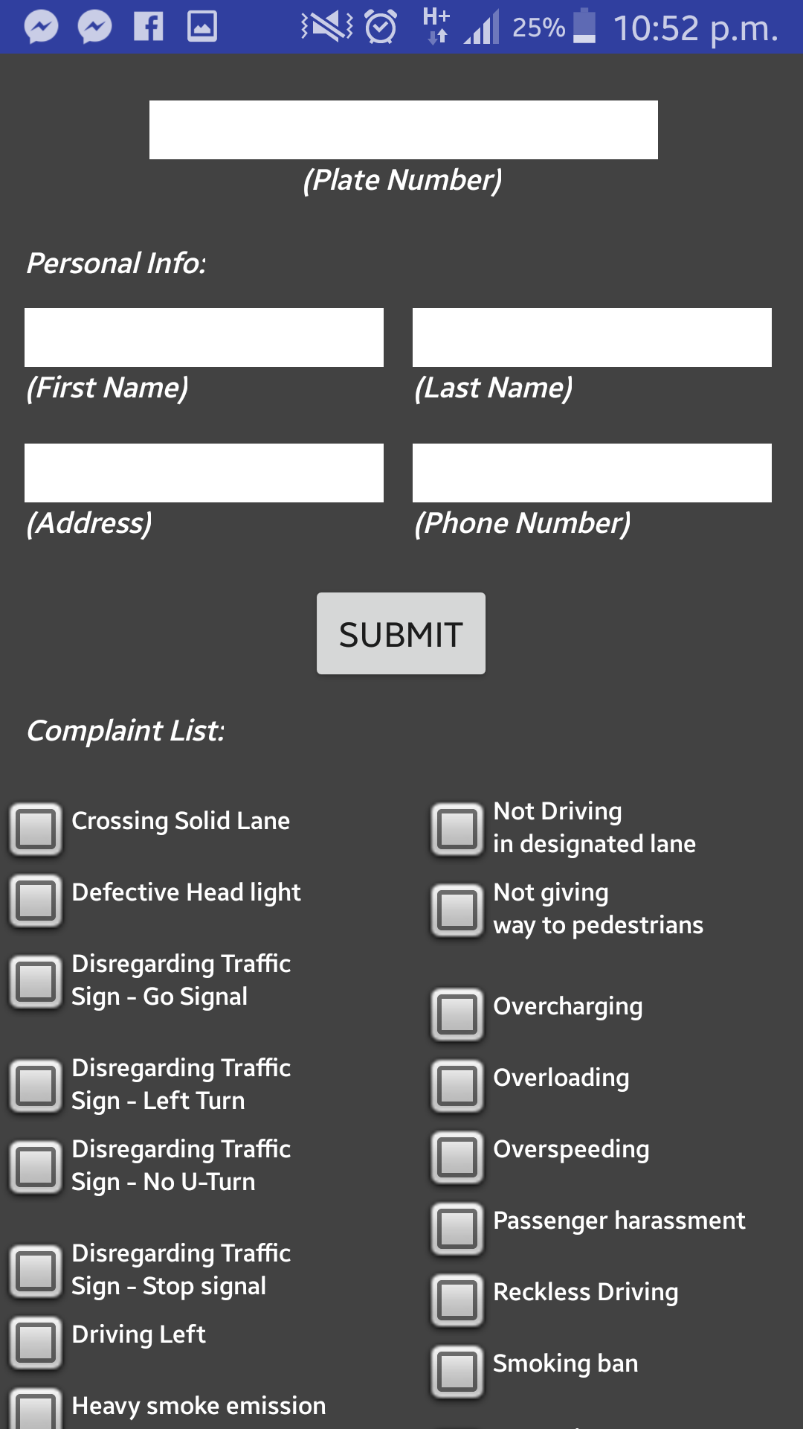

1

6

7

5

4

3

2

1.Input plate number of public vehicle

2.Input user first name

3.Input user last name

4.Input user address

5.Input user contact number

6.Select violation(s)

7.Tap to submit complaint

**COMPLAINT FORM: OTHER COMPLAINTS**

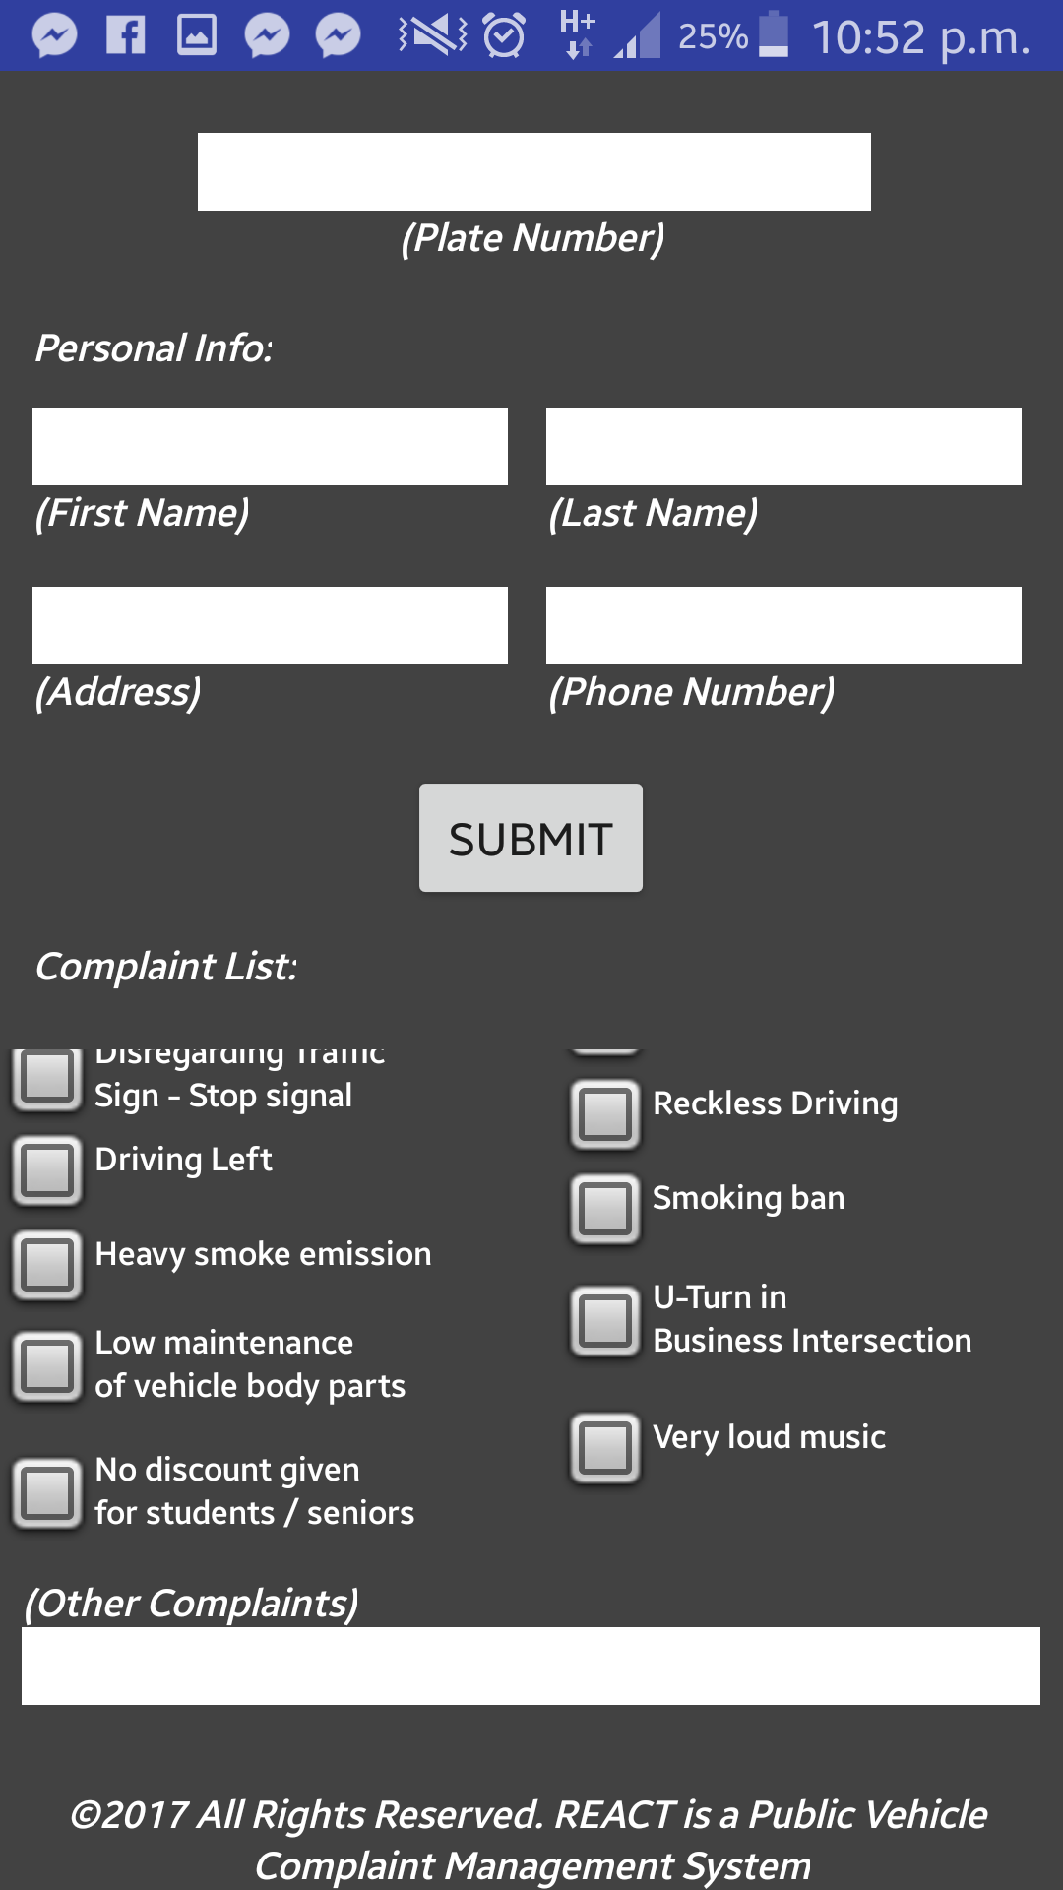

1

1. Input other complaint if complaint is unspecified in complaint list.

**Web Application Wireframe of the Public Vehicle Management System**

**Login Page**

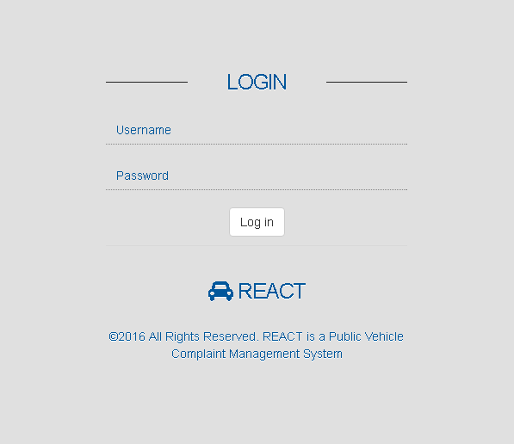

3

2

1

1. Username field - Enables the admin and operator to input his/her username. It should accept 3-12 characters.
2. Password field - Enables the admin and operator to input his/her password. It should accept 6-20 characters.
3. Log in button

* (admin) if the username and password are correct it will go to the admin dashboard (Page 10).
* (operator) if the username and password are correct it will go to the operator dashboard (Page 21).
* If username and password are incorrect, it would display a message “Invalid username and/or password”.
* If the username and password text fields are empty, it would display a message “Please input a valid username and password.”

**SUPER ADMIN DASHBOARD**

9

5

4

3

2

1

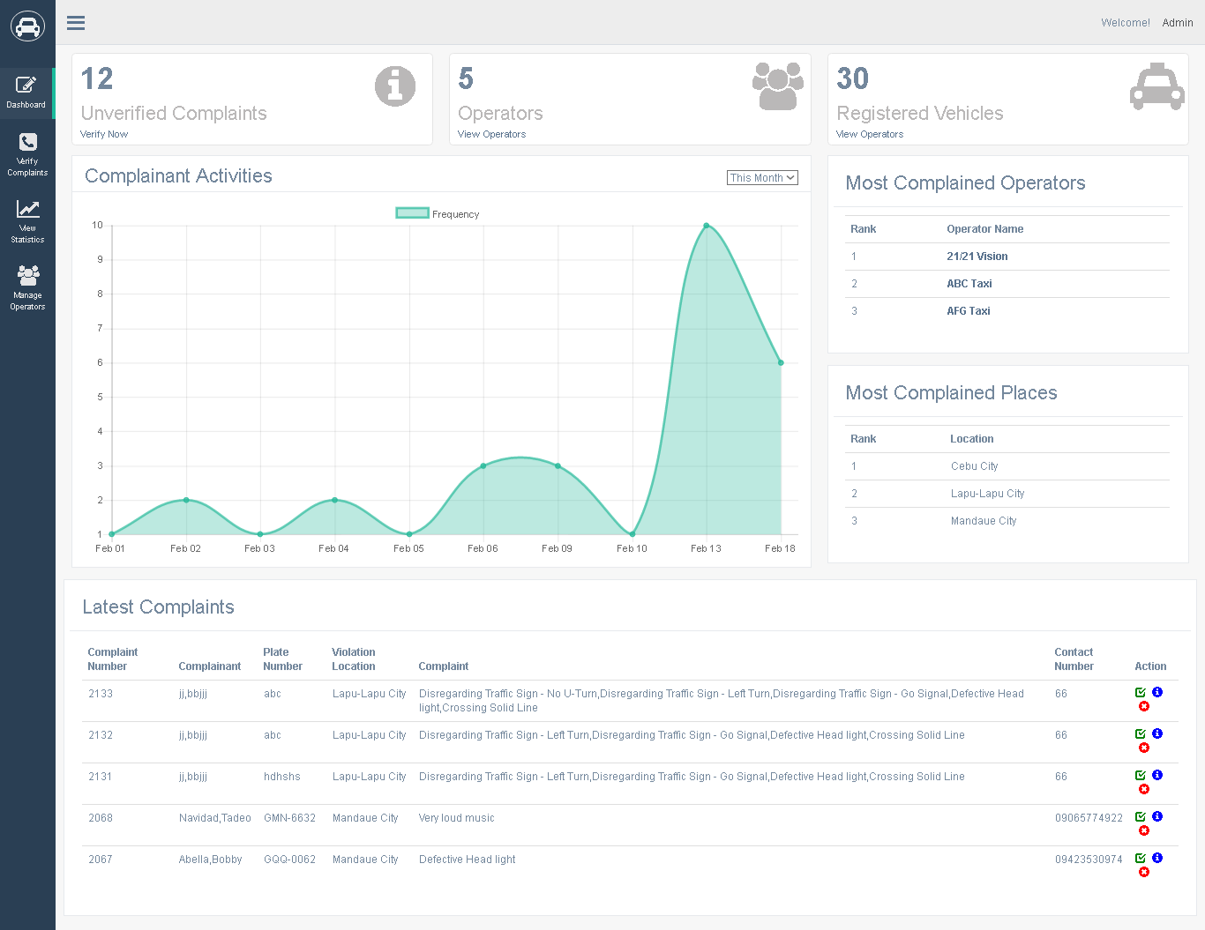

8

7

6

1. Unverified Complaints - Displays number of unverified complaints. Click verify now to redirect to **Verify Complaints** page (page 12).
2. Operators - Displays number of operators. Click view operators to redirect to **Manage Operators** page (page 16).
3. Registered Vehicles - Displays number of registered vehicles. Click view operators to redirect to **Manage Operators** page (page 16).
4. Displays graphical complaint frequency by month, week and day.
5. Displays most complained places.
6. Click to verify complaint. Prompts “Are you sure you want to verify this complaint?”.
7. Click to delete complaint. Prompts “Are you sure you want to delete this complaint?”.
8. Click to view complaint information. Redirects to complaints details page (page 13).
9. Click to go to dashboard.

SUPER ADMIN SIDE PANEL NAVIGATION

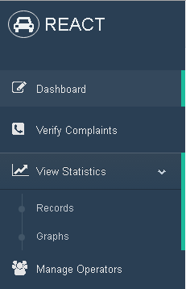

6

5

4

3

2

1

1. Click to go to dashboard page. (page 10)
2. Click to go to verify to complaints page. (page 12)
3. Click to show drop-down tabs: records and graphs.
4. Click to go to records page. (page 14)
5. Click to go to graphs page. (page 15)
6. Click to go to manage operators page (page 16)

**SUPER ADMIN VERIFY COMPLAINTS**

4

3

2

5

1

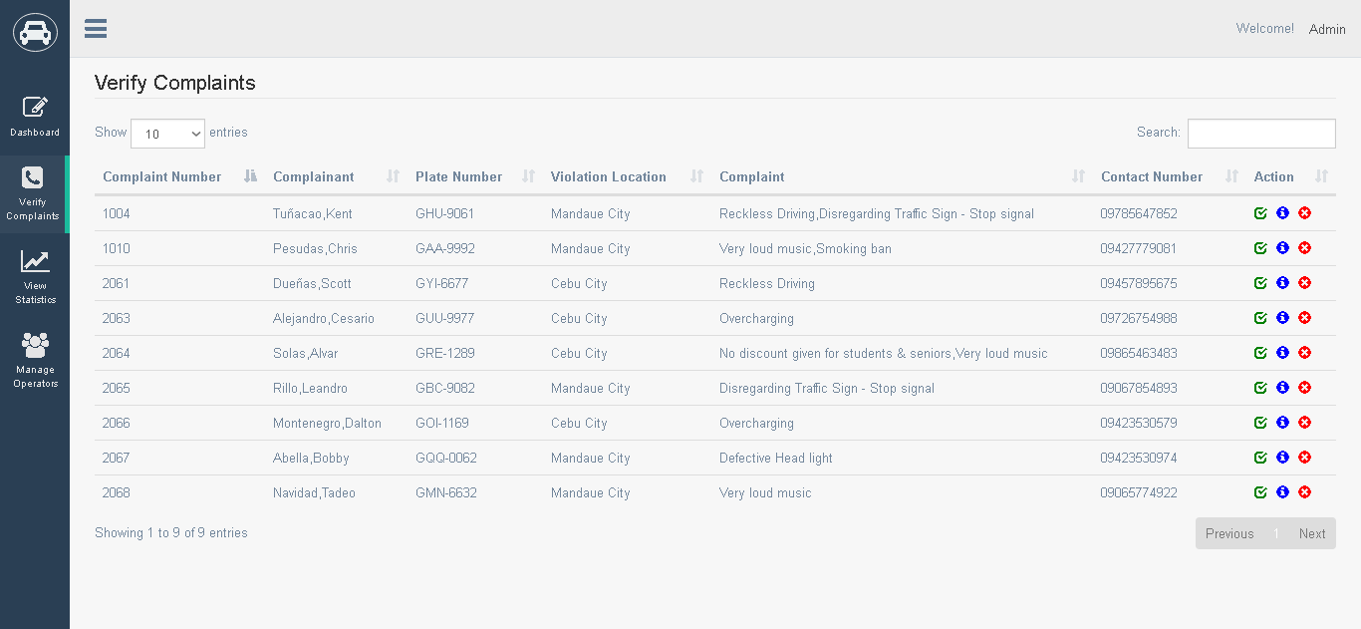

7

6

1. Click to choose desired number of entries to be shown.
2. Click to verify complaint. Prompts “Are you sure you want to verify this complaint?”.
3. Click to display complaint information. Redirects to complaint details (page 13).
4. Click to delete complaint. Prompts “Are you sure you want to delete this complaint?”.
5. Type in to search unverified complaint information.
6. Click to go to previous table page.
7. Click to go to next table page.

**SUPER ADMIN COMPLAINT DETAILS**

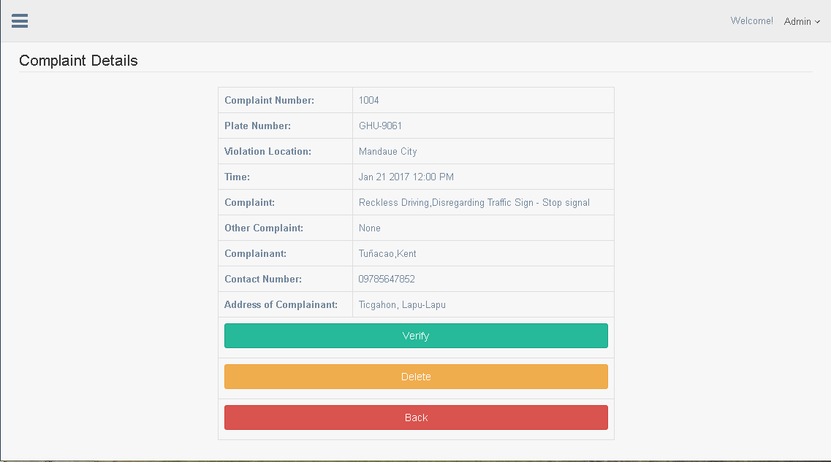

3

2

1

1. Click to verify complaint. Prompts “Are you sure you want to verify this complaint?”.
2. Click to delete complaint. Prompts “Are you sure you want to delete this complaint?”.
3. Click to go back. Redirects to previous page.

**SUPER ADMIN RECORDS**

6

5

4

3

2

1

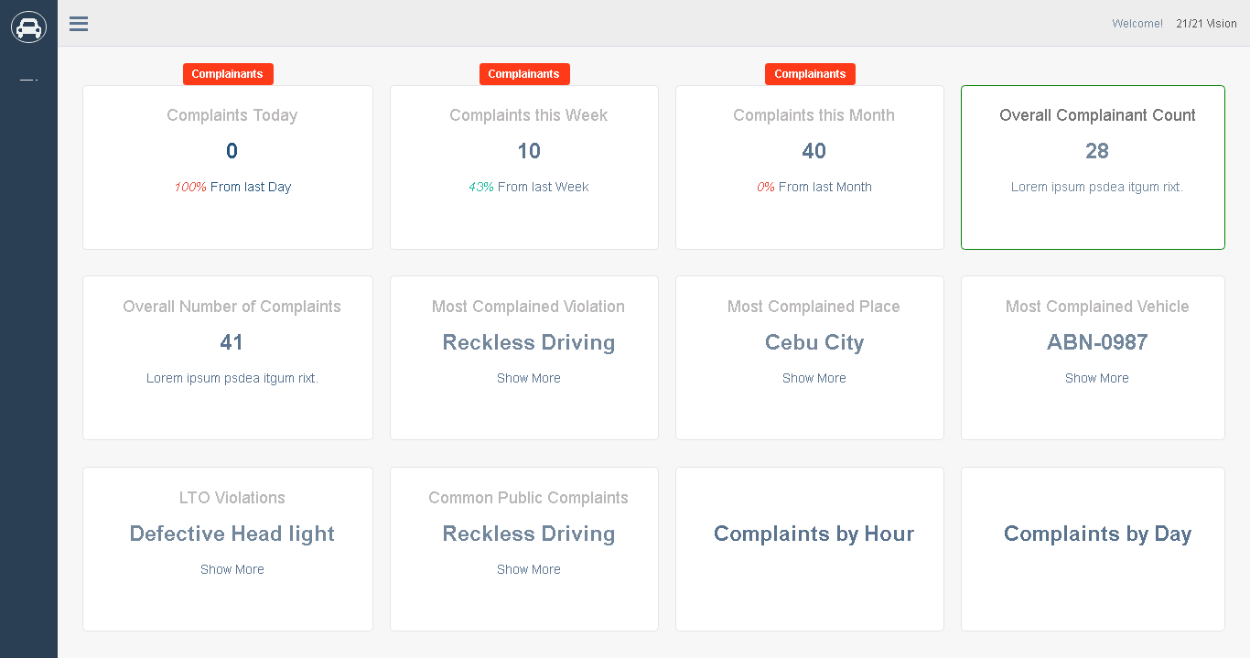

12

11

8

7

10

9

1. Displays complaints/complainants today.
2. Displays complaints/complainants this week.
3. Displays complaints/complainants this month.
4. Displays overall complaint count.
5. Displays overall number of complaints.
6. Displays most complained violation.
7. Displays most complained place.
8. Displays most complained vehicle.
9. Displays complaints by LTO Violations.
10. Displays complaints by Common Violations.
11. Displays number of complaints by hour.
12. Displays number of complaints by day.

**SUPER ADMIN GRAPHS**

8

4

3

2

1

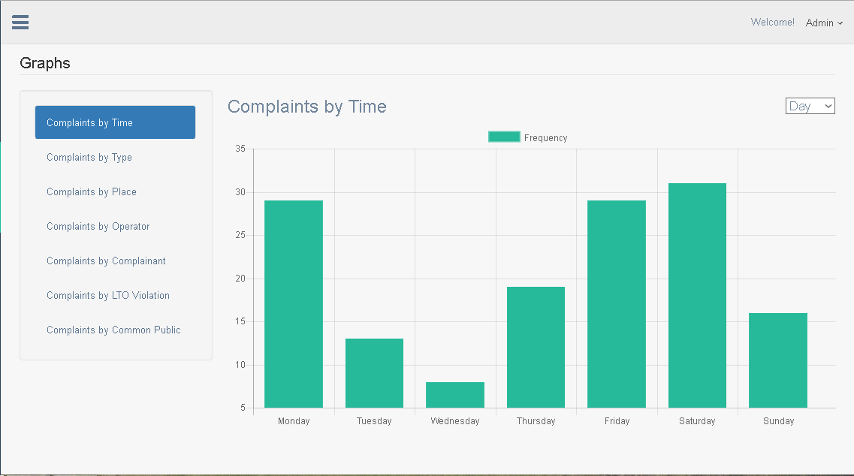

5

7

6

1. Click to display complaints by time.
2. Click to display complaints by time.
3. Click to display complaints by place.
4. Click to display complaints by operator.
5. Click to display complaints by complainant.
6. Click to display complaints by LTO Violation.
7. Click to display complaints by Common Public Violations.
8. Click to choose graph frequency by day, hour or month.

**SUPER ADMIN MANAGE OPERATORS**

3

4

5

6

2

1

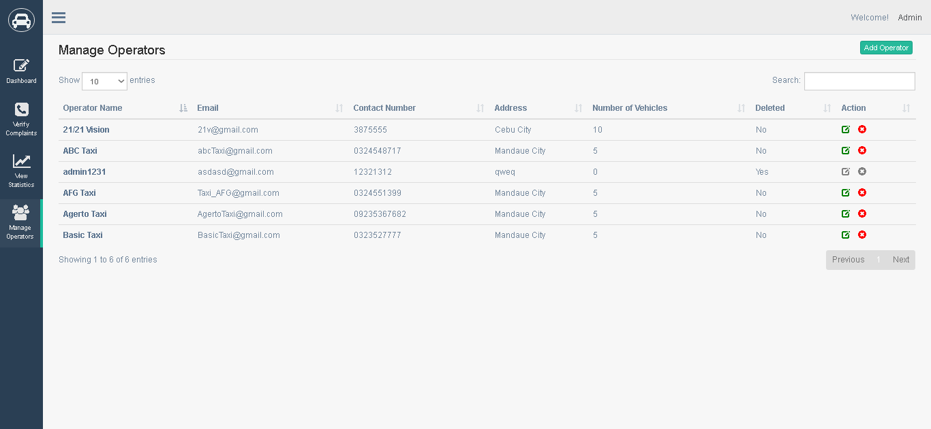

8

7

1. Displays operator name, click to display operator profile page. (page 17)

2. Click to choose desired number of entries to be shown.

3. Click to edit operator, opens operator information page. (page 17)

4. Click to remove operator, prompts “Are you sure you want to delete this operator?”.

5. Type in to search operator information.

6. Click to add operator, opens add operator page. (page 17)

7. Click to go to previous table page.

8. Click to go to next table page.

**SUPER ADMIN OPERATOR PROFILE**

1

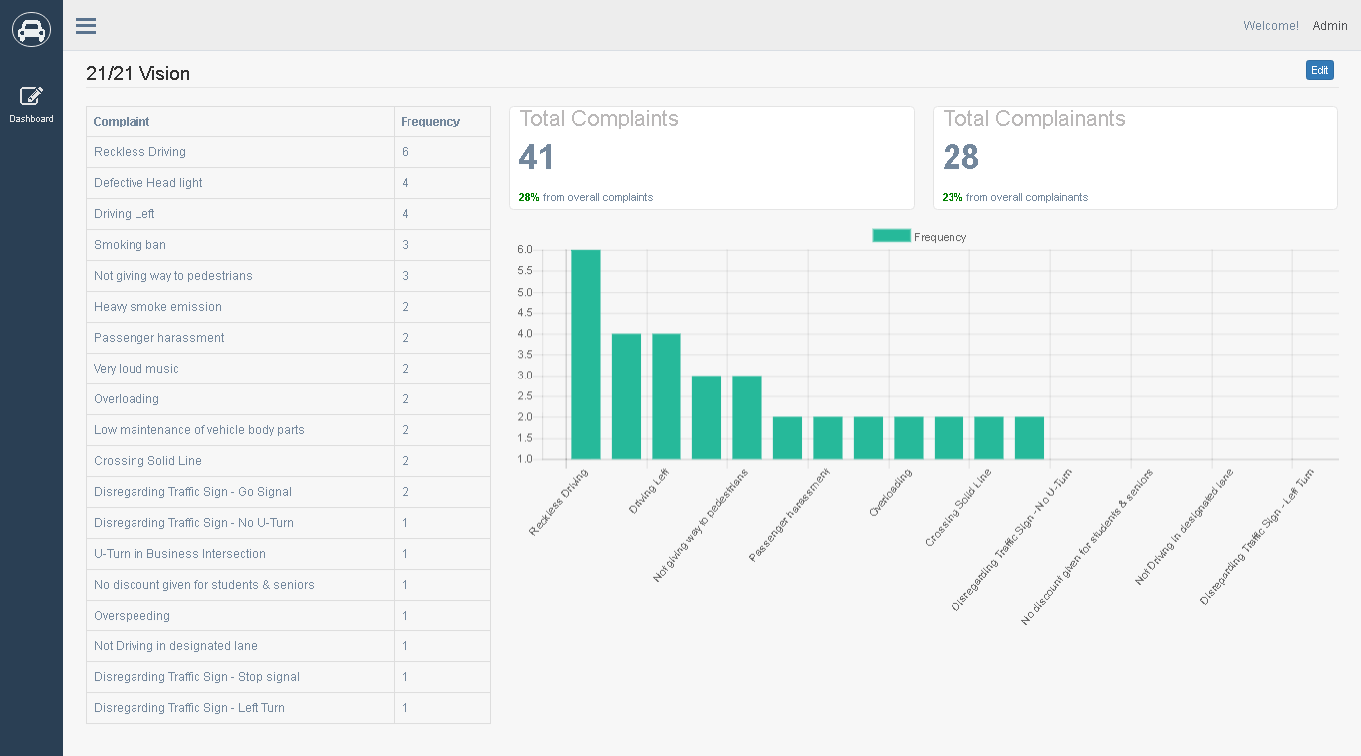

1. Click to edit operator, opens operator details page. (page 19)

**SUPER ADMIN ADD OPERATOR**

8

7

6

5

4

3

2

1

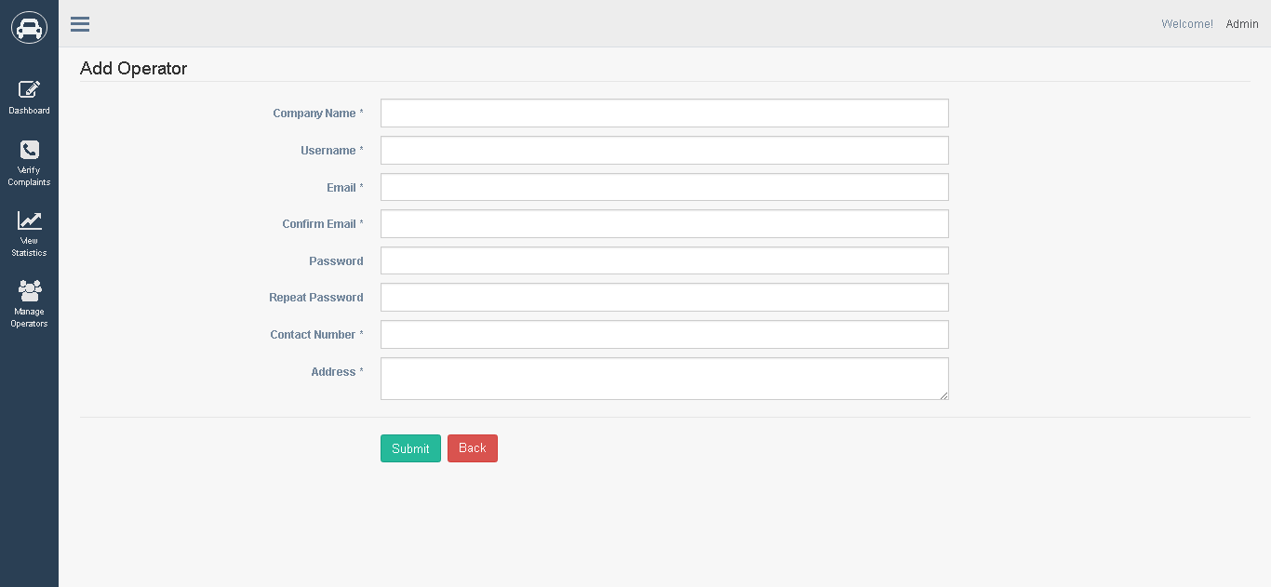

10

9

1. Input company name.

2. Input username. If username is invalid prompt “The Confirm E-mail field must contain a valid email address.”.

3. Input email. If email is incorrect, prompt “Please include an ‘@’ in the email address”.

4. Input confirm email address. If it doesn’t match, prompt ”The Confirm E-mail field must contain a valid email address.”.

5. Input password. Checks if inputted passwords match. If it doesn’t match, prompts “The Password field must be at least 6 characters in length. The Password field must be at least 6 characters in length.”

6. Input contact number. If number does not meet standards prompt “The Password field must be at least 6 characters in length.”.

7. Input contact number. If number does not meet standards prompt “The Password field must be at least 6 characters in length.”.

8. input address.

**SUPER ADMIN OPERATOR DETAILS**

6

5

4

3

2

1

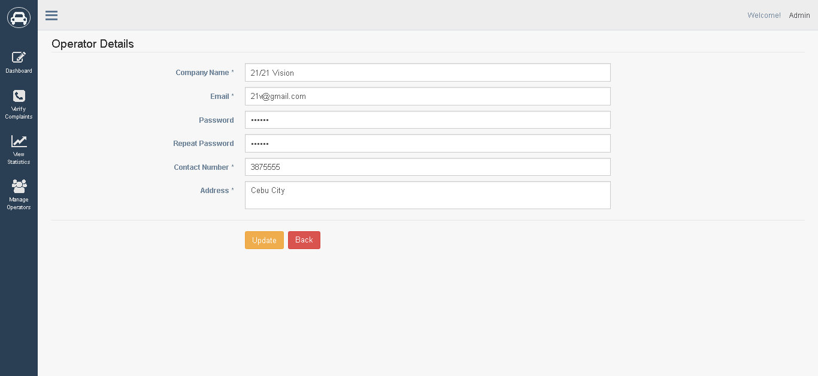

8

7

1. Input Company name.

2. Input Email.

3. Input password. Checks if inputted passwords match. If it doesn’t match, prompts “The Password field must be at least 6 characters in length. The Password field must be at least 6 characters in length.”

4. Input repeat password. Checks if repeat password is the same with password field. If it doesn’t match, prompt “The Password field must be at least 6 characters in length.”.

5. Input contact number. If number does not meet standards prompt “The Password field must be at least 6 characters in length.”.

6. input address.

7. Click to update operator details,

8. Click to discard changes and redirect to previous page.